Starvation Problem:

* If we put in producer

wait(full);  
        wait(mutex);  
        . . .  
        #add  to buffer  
        . . .  
        signal(mutex);  
        signal(full);

* if we put in consumer:

wait(full);  
        wait(mutex);  
        . . .  
       # remove item from buffer    
        . . .  
        signal(mutex);  
        signal(empty);

so if we replace wait condition in producer and consumer

it results in starvation. Starvation is the problem that occurs when high-priority processes keep executing and low priority processes get blocked for an indefinite time. Here producer and consumer process is not allowed.

another scenario:

* If we put in producer

wait(Empty);  
        wait(mutex);  
        . . .  
        #add  to buffer  
        . . .  
        signal(mutex);  
        signal(Empty);

* if we put in consumer:

wait(full);  
        wait(mutex);  
        . . .  
       # remove item from buffer    
        . . .  
        signal(mutex);  
        signal(full);

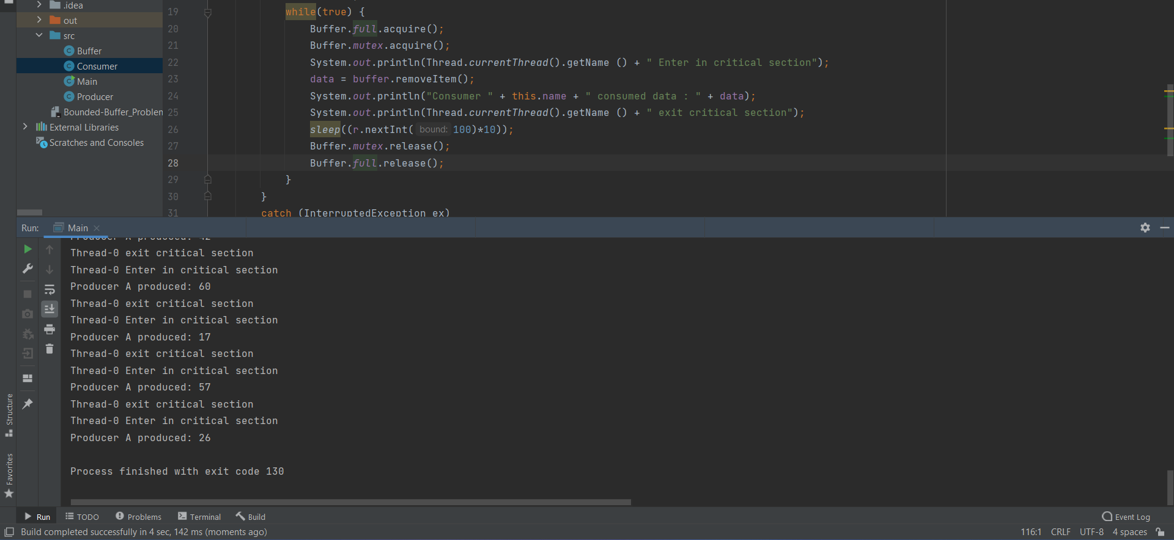

results in starvation. producer at condition wait(empty) blocks the process that there are no items to give and wait(full) in consumer conditions blocks that there is no item to consume because it is already full it means something blocking high-priority processes keep executing and low priority processes get blocked for an indefinite time.

Conclusion:

* Consumer on certain condition is not returning the previously consumed buffer to empty buffer queue and continuing to wait for next ready buffer ready to be consumed.
* Or Producer on certain condition is not returning produced buffer to ready buffer queue and continuing to wait for empty buffer to produce.
* Then eventually this kind of situation will lead to starvation.

Solution of Starvation:

The solution of starvation in this situation we must use (FIFO)queue to prevent starvation as first come first served to avoid thread from waiting